Christeen Safar

CSD - 340

04/1/2023

**Module 4 Assignment 4.2- Assignment: Build a Webpage Exercise, Part 4**

CSD 340 Web Development with HTML and CSS

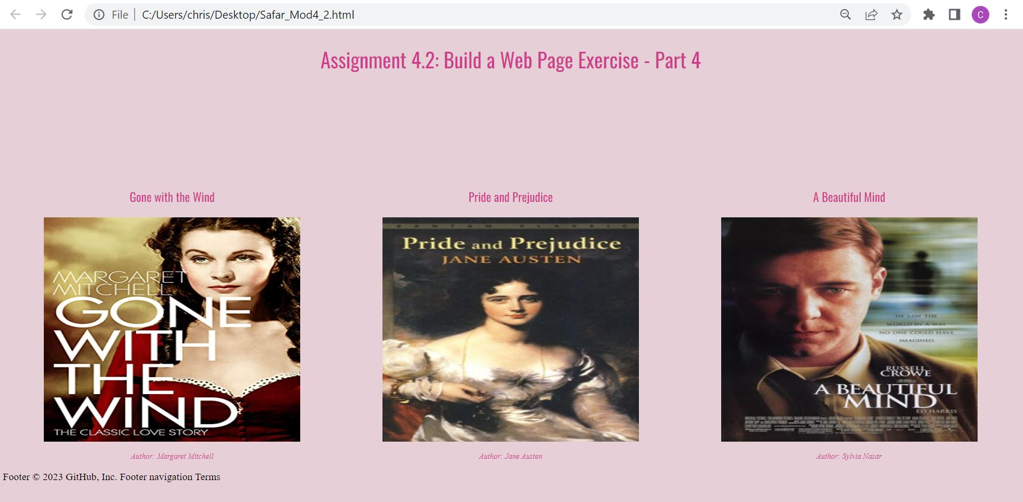

**GitHub Link:**

[**https://github.com/ChristeenSS/csd-340.git**](https://github.com/ChristeenSS/csd-340.git)

**URL to repositories GitHub pages website:**

[**https://christeenss.github.io/csd-340/**](https://christeenss.github.io/csd-340/)

**Assignment Details:**

**1. Assignment Instructions**

* Create a new folder under your local csd-340 folder (repository)  and name it module-4
  + Create a new HTML document and name it LastName_Mod4_2.html, add your name and assignment number (documentation), and add it to your module-4 directory
    - All HTML code will go in this file
  + Create a new CSS document and name it LastName_Mod4_2.css, and add it to your module-4 directory
    - All CSS styling will go in this file
  + Create a new folder and name it “images” and add it to your module-4 directory
  + Find or create an image of three(3) book covers from your list from last week. Save the images in your "images" folder.
  + Add a link in the index.html file to the HTML file
    - Hint: refer back to assignment 3.2 if you are confused about what this item is referencing
  + Contents of LastName_Mod4_2.html
    - Create an empty HTML document (follow the code we used in Module 3)
    - Give the HTML document a title of “CSD 340 Web Development with HTML and CSS”
      * This will be placed in the head/title element
    - Add a link to LastName_Mod4_2.css file in the HTML documents element
    - Add a main div to the body of the HTML document with an id of “container”
    - Main div
      * Add an h1 tag and give it a text value of “Assignment 4.2: Build a Web Page Exercise - Part 4”
        + Center the text on the page
      * On a new line add a new div and give it an id of “image-gallery”
      * Inside the image-gallery div add three side-by-side divs using CSS grids (see the resources section for assistance).  Each of these divs will contain a title, image, and captions.
    - 3 side-by-side divs
      * Inside each div add an h3 element with a description of the image you are using in that div
      * Under each div add a figure tag and inside the figure tag add one of the downloaded images (one figure per div, one image per figure)
      * Underneath each figure add a figure caption with the author's name using the format: (author: <insert author name here>)
      * Underneath the picture gallery, add a link back to the landing/portal page in the same position as 3.3.

<!DOCTYPE html>

<html lang="en">

  <head>

    <a name="top"></a>

    <meta charset="UTF-8" />

    <meta http-equiv="X-UA-Compatible" content="IE=edge" />

    <meta name="viewport" content="width=device-width, initial-scale=1.0" />

    <title>CSD 340 Web Development with HTML and CSS</title>

    <link href="Safar_Mod4_2.css" type="text/css" rel="stylesheet" />

    <link rel="preconnect" href="https://fonts.googleapis.com">

    <link rel="preconnect" href="https://fonts.gstatic.com" crossorigin>

    <link href="https://fonts.googleapis.com/css2?family=Oswald:wght@300;400;500;700&display=swap" rel="stylesheet">

</head>

  <body>

    <main div id="”container”">

        <h1>Assignment 4.2: Build a Web Page Exercise - Part 4</h1>

        <div id="image-gallery">

            <div class="image-card">

                <h3>Gone with the Wind</h3>

                <figure>

                    <img src="images/Wind.jpg" alt="Gone with the Wind" />

                    <figcaption>

                        <p>Author: Margaret Mitchell</p>

                    </figcaption>

                </figure>

            </div>

            <div class="image-card">

                <h3>Pride and Prejudice</h3>

                <figure>

                    <img src="images/Pride.jpg" alt="Pride and Prejudice" />

                    <figcaption>

                        <p>Author: Jane Austen</p>

                    </figcaption>

                </figure>

            </div>

            <div class="image-card">

                <h3>A Beautiful Mind</h3>

                <figure>

                    <img src="images/Mind.jpg" alt="A Beautiful Mind" />

                    <figcaption>

                        <p>Author: Sylvia Nasar</p>

                    </figcaption>

                </figure>

            </div>

        </div>

    </main>

  </body>

</html>

Footer

© 2023 GitHub, Inc.

Footer navigation

Terms

* + Contents of LastName_Mod4_2.css
    - Apply a CSS grid with three columns for the 3 side-by-side divs (see the above resources section for help/assistance)
    - Give the image-gallery div a margin-top of 10%
    - Center the h1 text
    - Center the h3 text (title for each of the image gallery items)
    - Apply text-align center to the figure tag  (this will basically center the image in the div)
    - Apply a font style of italic to the figcaption text and set the font-size to .75em
    - Using rgba, add a different color to the h1, h3, and figcaption tags. **optional**.

body {

    background-color: rgba(132, 18, 56, 0.2);

}

h1 {

    font-family: 'Oswald', sans-serif;

    font-weight: 400;

    color: rgb(207, 62, 140);

    text-align: center;

}

h3 {

    font-family: 'Oswald', sans-serif;

    font-weight: 400;

    color: rgba(207, 62, 140);

    text-align: center;

}

figure {

    text-align: center;

}

figcaption {

    font-style: italic;

    font-size: .75em;

    color: rgba(207, 62, 140);

}

img {

    width: 400px;

    height: 350px;

}

#image-gallery {

    display: grid;

    margin-top: 10%;

    grid-template-columns: 1fr 1fr 1fr;

}